1.Write a java program for Even and Odd.

import java.util.*;
public class Even{
public static void main (String[] args) {
Scanner sc=new Scanner(System.in);
int n;
System.out.println("enter a number :");
n=sc.nextInt();
if(n%2==0){
System.out.println("Even no" +n);
}
else{
System.out.println("Odd no" +n);
}
}
}

Output=

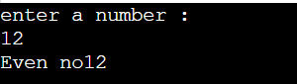

2.Write a java program for number is Divisible by 17 or not.

import java.util.*;
public class Divisible{
public static void main (String[] args) {
Scanner sc=new Scanner(System.in);
int n;
System.out.println("Enter a number :");
n=sc.nextInt();
if(n%17==0){
System.out.println("The given number "+n+" is Divisible by 17");
}
else{
System.out.println("The given number "+n+" is not Divisible by 17");
}
}
}

Output-

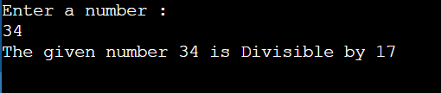

- Write a java program for given year is leap or not.

import java.util.*;
public class LeapYear{
public static void main (String[] args) {
Scanner sc=new Scanner(System.in);
int y;
System.out.println("Enter a number :");
y=sc.nextInt();
if(y%4==0){
System.out.println("The given number is leap year.");
}
else{
System.out.println("The given number is not leap year");
}
}
}

Output-

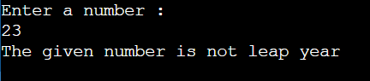

- No is divisible by 5&7.

import java.util.*;
public class MultiDivisible{
public static void main (String[] args) {
Scanner sc=new Scanner(System.in);
int n;
System.out.println("Enter a number :");
n=sc.nextInt();
if(n%5==0 && n%7==0){
System.out.println("No is divisible by 5 and 7");
}
else{
System.out.println("No is not divisible by 5 or 7");
}
}
}

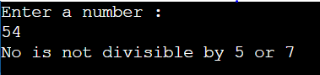

- Write a java program for display manimum of two numbers.

import java.util.*;
public class Minimum{
public static void main (String[] args) {
Scanner sc=new Scanner(System.in);
int a,b;
System.out.println("Enter a number :");
a=sc.nextInt();
System.out.println("Enter a number :");
b=sc.nextInt();
if(a<b){
System.out.println("A is Minimum number");
}
else if(b<a){
System.out.println("B is minimum number");
}
else{
System.out.println("both number is equal");
}

}
}

Output=

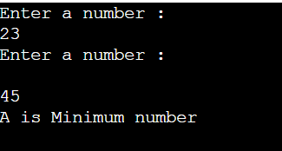

6.Write a java program for display maximum of two numbers.

import java.util.*;
public class Maximum{
public static void main (String[] args) {
Scanner sc=new Scanner(System.in);
int a,b;
System.out.println("Enter a number :");
a=sc.nextInt();
System.out.println("Enter a number :");
b=sc.nextInt();
if(a<b){
System.out.println("A is maximum no");
}
else if(a<b){
System.out.println("B is maximum no ");
}
else{
System.out.println("both number is equal ");
}

}
}

Output:

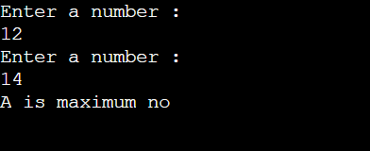

- Write a java program to cheak number is positive or not.

import java.util.*;
public class Positive{
public static void main (String[] args) {
Scanner sc=new Scanner(System.in);
int n;
System.out.println("Enter a number :");
n=sc.nextInt();
if(n>0){
System.out.println("Number is Positive");
}
else if(n<0){
System.out.println("Number is Negative");
}
else{
System.out.println("Number is zero");
}

}
}

Output=

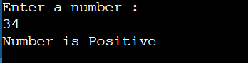

- Wrire a java program to Accept a,b,c number from user and cheak a number is betwwen b & c

import java.util.*;
public class Between{
public static void main (String[] args) {
Scanner sc=new Scanner(System.in);
int a,b,c;
System.out.println("Enter three number :");
a=sc.nextInt();
b=sc.nextInt();
c=sc.nextInt();
if(a>b&&a<c){
System.out.println("A is between b and c");
}
else{
System.out.println("a is not between b and c ");
}

}
}

